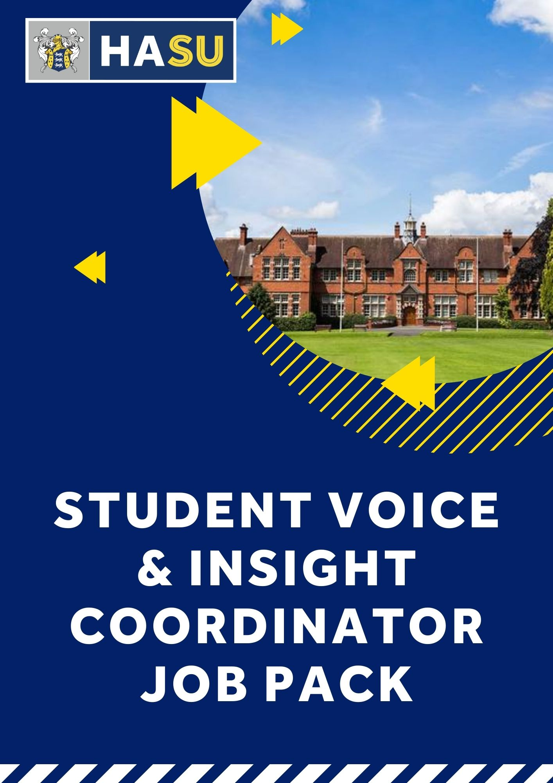

Dear Candidate,
Thank you for your interest in joining the Students’ Union at Harper Adams University. Please take the time to read all the information in this recruitment pack and if you have any further questions, please feel free to send me an email to organise a time to have an informal chat. You can reach me on LDavis@Harper-Adams.ac.uk
Over the past year the organisation has undergone a number of significant, positive changes. We are in the process of finalising a new strategic plan to set out what we want to achieve in the coming years. We have been through a full organisational review, professionalising how our organisation should run. The development of our student voice provision is now front and centre of our vision.
We’re looking for an ambitious, creative and hard-working coordinator with a passion for working with young people. You must be a well organised people person, capable of driving improvements in your area. You don’t need to have worked within a students’ union before. This role is key in ensuring that we understand our students and can operate in line with their needs. It is also critical to our work as a union representing our students and their views to the university. This is a new role and has massive potential for development. We hope that the successful candidate will build on what we have started but you’ll have relative freedom in how you achieve our aims.
We’re extremely excited about our future. As such, we’re looking for talented people who can help take the Students’ Union to the next level. In return you’ll be joining a vibrant, enthusiastic and ambitious staff team looking to become the best at everything we do. Best of luck with your application and we look forward to meeting you.

Liam Davis Jess Milbank
Union Director Union President

ABOUT US
Based on a campus situated in rural, scenic Shropshire, the Students’ Union is a student led organisation that represents all students at Harper Adams University. We have over 4,000 HE students attending the University College, primarily on sandwich courses which include a year-long industrial placement. Harper Adams University was voted Modern University of the Year in 2020 and is the premier UK Higher Education institution focused on land-based and food supply-chain education. The Students’ Union is a registered charity with a turnover of circa £1 million each year. It sits at the heart of student life and encompasses representation, welfare, clubs and societies, along with our trading services (a shop, a bar and a pub).
PURPOSE OF THE ROLE
The Student Voice and Insight coordinator will be responsible for developing a knowledge bank of understanding on key issues by ensuring that student voice is an integral part of every activity we do. Each interaction with our members, through either commercial or membership activities, should have student voice at its heart. We will collate and analyse the information garnered and relay key issues to the relevant areas of the institution. To do this you’ll need to work with our course reps and student officers to deliver success

JOB DESCRIPTION – Student Voice & Insight Coordinator
Application Deadline: Midday, Friday 26th August

Salary: £25,368
Reports to: Union Director

Application Instructions: To apply please send a cover letter explaining how you meet the Person Specification and any experience you feel is relevant and related to the job description below. Please supplement this with a CV. Cover Letters and CV's should be sent to the Union Director: LDavis@harper-adams.ac.uk.
Job Description
The Student Voice & Insight Coordinator will be responsible for supporting our course rep system and student officer team to identify key issues and themes within our student body and to facilitate their resolution with the university. This roles key focus will be on understanding our student body’s needs from their union and their university.

Summary of Principal Duties
- To develop a knowledge bank of understanding on key issues by ensuring that student voice is an integral part of every activity we do. Each interaction with our members, through either commercial or membership activities, should have student voice at its heart. We will collate and analyse the information garnered and relay key issues to the relevant areas of the institution.
- To support the election, training and co-ordination of course reps for HASU
- To centralise student feedback and support the elected officers to identify key themes
- To identify and lead on ways to collect student feedback and opinions about life at HAU, the services of HASU and issues that our students care about.
- To provide support to the President and Vice President by providing up to date information about student views and opinions.
- To lead on the delivery of the main annual SU elections.
- To support and develop an appropriate structure for academic representation to ensure that attendance at University Boards, Committees, course management committees etc, is as effective as possible.
- To liaise with academic departments and key university staff on student feedback.
- To support the part time SU officers to produce annual plans and provide guidance in their work.
- To produce the student voice reports and associated survey/analysis.
- To ensure the broader staff team have appropriate feedback on their areas to ensure constant development can take place across the union.
- Administrative support for the effective day to day running of the union in regards to academic and/or student representation.
Working with Harper Adams University
- To be the key contact between HAU and HASU course reps and student voice
- To form and develop productive and professional relationships with key University departments.
- To be aware of the Memorandum of Agreement between HAU and HASU, and in liaison with the Students’ Union Director, ensure that all work carried out by the Students’ Union adheres to this document.
- To act as an ambassador, leader and promoter of the non-academic student experience in support of the Students’ Union and the University.

General Expectations

• Keep yourself and others safe by maintaining high standards of Health and Safety and adhering to other relevant law and regulations.
• Maintain the highest standards of Confidentiality and Data Security, in accordance with the General Data Protection Regulations 2018.
• Comply with the policies, procedures, and protocols in place within the Students’ Union. These are available from the Employability and HR department or from the Staff Intranet.
• Maintain a good knowledge of Higher Education policy, University policies and the main issues, which matter to our students
• Contribute to the delivery of the annual Student Welcome activities to support the Students’ Union in delivering a high-quality experience for returning and new students.
• Contribute to the ongoing facilitation of student voice and feedback to both our University and the Students’ Union, including the promotion of relevant surveys including the NSS.
• Any other duties as commensurate with the role.

This is a description of the post as it is presently constituted. The Students’ Union reserves the right to periodically examine an employee's job description and to up-date or amend it to ensure that it is related to the duties then being performed, or to incorporate new duties, as required.

Summary of Terms and Conditions
The role is based on a 35 hour working week.
Holiday entitlement will be 25 days plus 8 statutory public holidays.
The notice period for this post is two months.
HASU offers a contributory pension scheme, in which you may choose to participate.
Free Gym Membership
A cash healthcare plan

PERSON SPECIFICATION

The following sets out the range of personal qualities, skills and experience that the preferred candidate will be able to demonstrate.

QUALIFICATIONS | Essential | Desirable
A good standard of written and spoken English | X
A good general standard of education | X
EXPERIENCE AND SKILLS
Strong administration skills | X
Experience of having coordinated groups of people |  | X
Experience of working in a Educational environment |  | X
Proven experience of coordination of volunteers |  | X
Excellent interpersonal, communication and negotiation skills | X
Strong IT skills | X
Proven ability to multi-task and meet tight deadlines | X
Understanding of student interests |  | X
Experience of analysing data or feedback |  | X
The ability to build strong relationships quickly | X
Experience of having developed areas of work independently |  | X
INTERPERSONAL SKILLS
Approachable nature. Being able to mix with a range of people from diverse backgrounds. | X
Positive attitude, with a “can do” approach. | X
Desire to work in a student environment within democratic structures. | X
Committed to the principles and practice of equal opportunities, to include trust and respect for others. | X
Empathy with the aims and values of the Harper Adams Students’ Union. | X

COMPETENCIES

Accountability: takes personal responsibility for the part they play in our student body and wider society.

Student focus: keeps the needs of students at the heart of activities.

Personal effectiveness: consistently role models high standards and good practice.

Inclusivity: applies an understanding of equality and diversity to strengthen positive engagement in all our students’ union’s activities and services.

Results focused: maintains commitment to targets and results, striving consistently to achieve them.

Communications: helps to provide clear, consistent and appropriate messages at all levels of our students’ union and beyond.

Political awareness: applies an appreciation of the political environment in which our students’ union operates.

Motivational leadership: actively leads, establishes expectations, accountabilities, purpose and vision, creating an environment where others can achieve optimal performance.

