HARPER ADAMS STUDENTS’ UNION
Student Voice Report
Term Two 2021/22

Introduction
Towards the end of Term Two, the Students’ Union opened up the second student voice survey for the 2021/22 academic period. This survey was intended to gather further demographic details of students…, strategic feedback to help with drafting our Union strategy, importantly gain an understanding of campaign topics students would like us to look into. A total of 423 students completed the survey; their results were then analysed using both quantitative and qualitative analysis.

Executive Summary
The key information in this survey has been drawn from a combination of quantitative and qualitative data, which has been analysed and themes identified in qualitative data.

Online Study
Students were generally positive about online study although raised concerns around the consistency in the delivery between modules. There were clear positives of online study such as greater flexibility and the recording of lectures enabling students to revisit teaching material and the ability to go at their own pace. HASU is in discussions with the University on its work in embedding lecture recording equipment in lecture theatres.

Face to Face Study
Students were generally grateful for an increase in face to face study and strongly value the practical elements of their study to reinforce the material they are being taught. Students would like to see lectures being recorded now the majority are carried out face to face; this information has been fed into the LTSEC committee.

Students’ Union Strategic Planning
The feedback on this section has shown the interests and values of students, which will now be embedded into our strategic planning. Students highlighted that they wanted to see HASU focus its time and resources on increasing the number of opportunities for students to make friends, having their needs and views represented to the University and introducing ‘just for fun’ sports. It also highlighted that students wanted HASU to continue the work it does to run balls and special events as well or weekly nightlife activity.
Respect
In light of the one year anniversary of the Respect Policy (a joint piece of work between the Students’ Union and the University), we asked students what respect meant to them, with a strong emphasis on listening, fairness and equal opportunities. Most feel they can be themselves at University, however they don’t feel others can, which certainly needs addressing. This data will be fed into the work the Union and University is doing as part of the review of the Respect Policy.

General Students’ Union Feedback
Questions in the final section related to campaigns (a mixed bag of results from sustainability, to supporting farms and fundraising) what students would like to see the Union organise such as trips and fundraising opportunities, as well as looking at what events or activities are demanded in the venues such as karaoke and pool tournaments. This feedback is being used to help us plan our activities for 2022/23 as well as to build our strategic plan.

Executive Conclusion
From the feedback received from students, it should be recognised that they:
- Are keen to keep some elements from online teaching such as recorded lectures
- Value practical sessions highly, although would like to have more trips.
- Would like a variety of events throughout the year, such as sports, fundraising activities, non-alcohol/reduced-alcohol events.
- Want to see value for money at events
These findings have been shared with the Learning, Teaching and Student Experience Committee (LTSEC) and other key members of staff. HASU will continue to work with the University to ensure steps are taken to make change across the campus. The Students’ Union will continue to work on the Union’s strategy, which aims to work in harmony with the University’s strategy and vision for the future.

Student Voice Report
The below information summarises the key findings, which was mostly analysed using thematic analysis. For a more in depth look at the quantitative data, please see appendix 1.

In comparison to the Term One report for 2021/22, we decided to ask more questions relating to demographics. The table below shows a comparison between the data collected in the Harper survey versus 2022 data from WONKHE regarding UK student statistics. One of the explanations for the difference between the data sets is likely to be the lower number of students who have accepted or are open with their sexuality at Harper. Applying comparison rules to Harper data and looking at sexuality and gender, 96% of males identified as heterosexual, 3% as gay and 1% preferred not to say, whereas 90% of females identified as heterosexual, 6.25% as bisexual, 1% as other and 2.75% preferred not to say.
Table 1: Sexuality Demographics
Sexuality | Harper | WONKHE | Difference
Heterosexual | 91% | 70% | +21%
Bisexual | 4.5% | 14% | -9.5%
Gay or lesbian | 1% | 4% | -3%
Use another term | 1% | 4% | -3%
Prefer not to say | 2.5% | 8% | -5.5%

Table 2: Ethnic Background Demographics
Ethnic Background | Harper | WONKHE | Difference
White | 98.25% | 64% | 34.25%
Mixed ethnicity | 1% | 6% | -5%
Black | 0% | 7% | -7%
Asian | 0.25% | 19% | -18.75%
Arab | N/A | 1% | N/A
Other | 0.5% | 1% | -0.5%
Prefer not to say | N/A | 2% | N/A

Table 3: Disability Demographics
Disability | Harper | WONKHE | Difference
Disabled | 22% | 14% | 8%
Non-disabled | 78% | 81% | -3%
Prefer not to say | N/A | 5% | N/A

Online Study
We still felt that it was appropriate to include a section relating to online study, despite more teaching moving back to face-to-face. The average satisfaction score for online teaching was 66%. There were a range of views and opinions explaining satisfaction scores.
The Students were then asked to give positive or negative feedback relating to online learning and the main themes have been highlighted below.
Positive feedback included:
- The ability to re-watch lectures
- Feeling more comfortable at home
- Able to go at their own pace
- Greater flexibility

Negative feedback included:
- More difficult to engage and ask questions
- Some lecturers difficult to understand online
- Easier to fall behind with online lectures.

However, students did make reference to the differing quality of online teaching between lecturers and modules. It was pointed out that students found online sessions more engaging when challenged with interactive sections such as Mentimeter or Kahoot. As mentioned in the previous student voice report, late uploads of lecture material need to be sorted in order for students to feel more satisfied; there has been an 8% increase in students experiencing a late upload since the last report (63% to 71%).
The average satisfaction score for availability of online resources was 77%. Students were asked to justify their answer with the main themes below.
Positive feedback:
- Great range of online resources on HOLLY for the majority of course areas
Negative feedback:
- Would like online wellbeing and academic support to be advertised more
- Students not being aware of the level of resources available online
- Wellbeing appointments being far apart or not be followed up
- Lack of resources/journals for some course areas – veterinary physiotherapy, bioveterinary science, veterinary medicine and surgery
- Resources and lectures uploaded in different areas and formats to help be more organised

Face to Face Study
Since the last student voice report, a higher amount of face to face teaching has resumed. The satisfaction score for face to face study was 80%
Positive feedback
- More engaging
- Able to ask questions throughout the lecture
- Easier to communicate
- Lecturers can read the room
- Socialisation
- More interactive
Negative feedback
- Miss printed out lecture notes
- More difficult to catch up
- Takes more time out of your day to do other academic work (e.g. travelling time)
- Not enough practical sessions
Strong desire for lectures to be recorded even when they are in person to enable students to catch up or revisit lectures.
The top resources cited to benefit the face to face study experience were:
- Recording lectures
- Practicals
- High quality handouts/physical materials
- Field trips/external trips
- Resources such as Kahoot/Menti/online quizzes
- Text books
- Access to previous years lectures/content
- Charging ports

Students’ Union Strategic Planning
It was felt appropriate to include a short section to help the Union with its strategic planning and gauge students’ interests and where perhaps the Union needs to shift its focus. It was interesting to learn that students prioritised opportunities to make friends as the most important, ahead of having needs/thoughts/views on academic life represented to the University and events, sports teams, societies and activities.
In terms of activities students would be interested in getting more involved, the top five answers were club nights/parties, live events (e.g. music gigs, theatre, comedy), community events (e.g. BBQs, picnics, fayres), trips abroad and ‘just for fun’ sports/exercise classes. It is interesting to see that ‘just for fun’ ranked higher than sports clubs and competitive sports.
These responses will all feed into shaping the HASU strategic plan.
Respect
We asked a number of questions relating to respect and equality, diversity and inclusion (EDI). Analysing the data showed that although there was little difference between gender identity, when it came to sexual orientation, 25% of bisexual students felt like they couldn’t be themselves at University; this was the only demographic that stood out when rules were applied and this points at the need to work on ensuring Harper is an inclusive and safe space for all students. They did say that they believe their peers can be themselves.
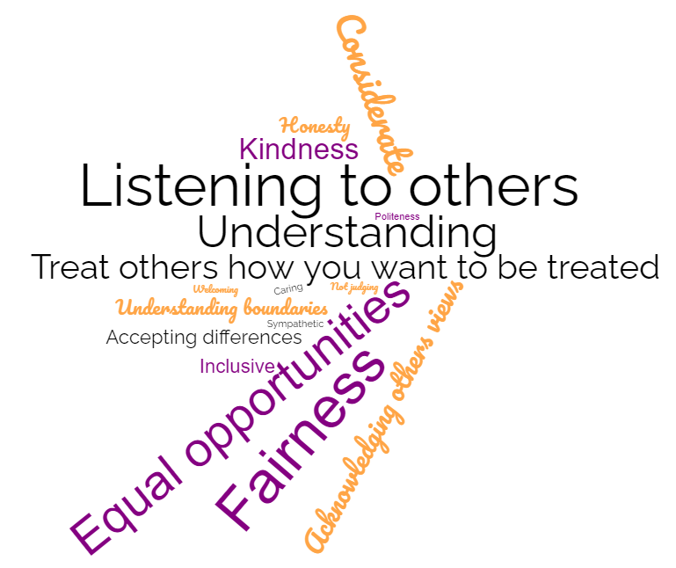
Figure 1: What Does Respect Mean to You?
The figure above shows what respect means to the students, with fairness, equal opportunities, listening, understanding and treating others how you want to be treated featuring highly. Considering this, 92% students felt they could be themselves at University, compared to 78% feeling their peers can feel themselves. 78% students felt they are treated respectfully by students and 86% felt respected by staff. There is clear work that needs to be done to ensure that all students can feel themselves and that students feel they are able to speak freely at University. At present, only 71% students felt they could speak freely.

Furthermore, 29% felt that the University’s approach to equality, diversity and inclusion (EDI) requires improvement compared to 27% for the Students’ Union. Interestingly, when we broke it down we found that 75% of gay/lesbian students said that EDI improvements needs to be made by both the University and the Students’ Union and an average of 47% of bisexual students felt that improvements need to be made across the University and the Students’ Union.

Over 1 in 4 (34%) students stated they would not know how to raise an issue related to EDI. This is a concerning issue and routes to make reports such as the anonymous reporting service on the University website need to be promoted more to students.

General Students’ Union Feedback
This section ranged from questions relating to the venue, to feeling part of the Harper community, and asking students what campaigns they would like to see us running.
Just under 1 in 4 (24%) students do not feel satisfied that they feel part of the Harper community and 1 in 4 students (24%) do not feel safe at HASU events in The Barn.
Top activities that students want to see us run in The Welly:
- Comedy nights
- Karaoke (this has been run for the first time this year)
- Quiz nights
- Pool and darts tour
- Tasting evenings (e.g. wine and cheese)
- Talent shows
- Live sport
We asked students which events they enjoyed the most. The top answer for this was the large balls that we have run this year (Christmas and Paddy’s). It must be noted that we were unable to run Freshers’ Ball this year due to Covid restrictions, however at the time of writing this report, planning is well underway for the first Summer Ball since 2019. Other events students have enjoyed included karaoke, bingo, guest DJ’s (e.g. Wilkinson and Sigma), themed nights (including LGBT+ rainbow night), six nations, Big Weekend, Hobgoblins. One to make particular reference to is rainbow night, this is the first time we have run an event like this in support of LGBT+ history month and despite some apprehension, it was very well received. There have been requests for more themed nights and barn dances.
The average price students thought was fair to pay for a standard Wednesday night was £6.20. Responses were mixed as to whether bus prices should or shouldn’t be included within the ticket prices and also requests for mini buses to go to The Barns at Adeney and Tibberton.

What could we do to improve our venues:
- Themed Wednesday nights
- More bar staff
- Faster bar service
- Toilet cleanliness
- More bars
- More/better decorations for Balls
- Extended opening hours
- Cheaper drinks
- Alcohol free nights
- A range of music – e.g. play different genres, such as a DnB week, Indie week etc.
- Areas to sit outside for fresh air
- Improved bus queuing system
It is important to note the “cheaper drinks”. In previous years, drinks had not been priced correctly and were too cheap. Since the appointment of the new venue manager, the price of drinks have been increased, however comparisons to other Students’ Unions and local venues have shown that we are on par and if not cheaper than others in certain areas, apart from pints. Some students also raised concerns regarding security being too strict, these were mostly final year agriculture students.

The data shows there is a place for alcohol free activities, with 37% students stating that alcohol activities are important to them. It would be for the next survey to look into the types of alcohol free activities these students would like to ensure engagement is as high as possible.

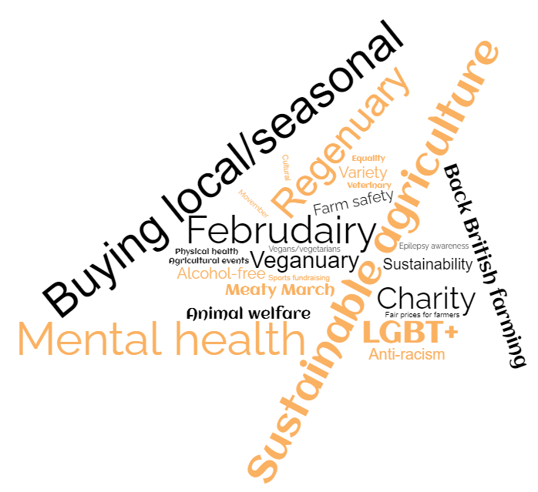
In terms of what students want to see from campaigns, it must be noted that the results may have been skewed slightly due to an issue arising from Februdairy this year.
Figure 2: What Campaigns Would You Like to See the Students’ Union Run?

Strong desire for us to promote all NFU campaigns and promote red tractor to students. Specific mention of mental health in farming an informative campaigns about microaggressions such as racism and sexual identity.
As the final question, we asked students whether there was anything else they thought we should organise, responses are shown in the word cloud below.
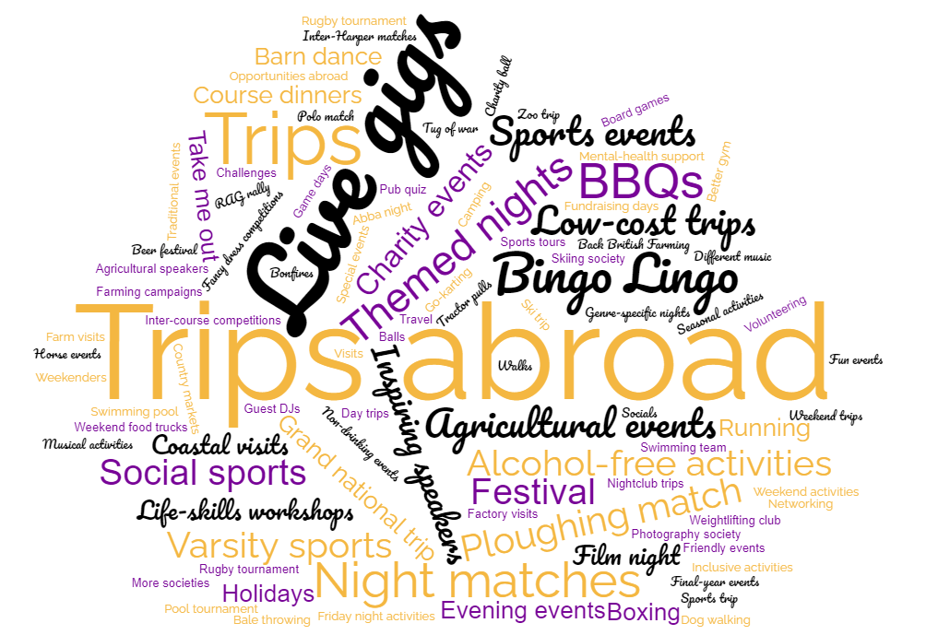
Figure 3: What Would You Like to See the Students’ Union Organise?

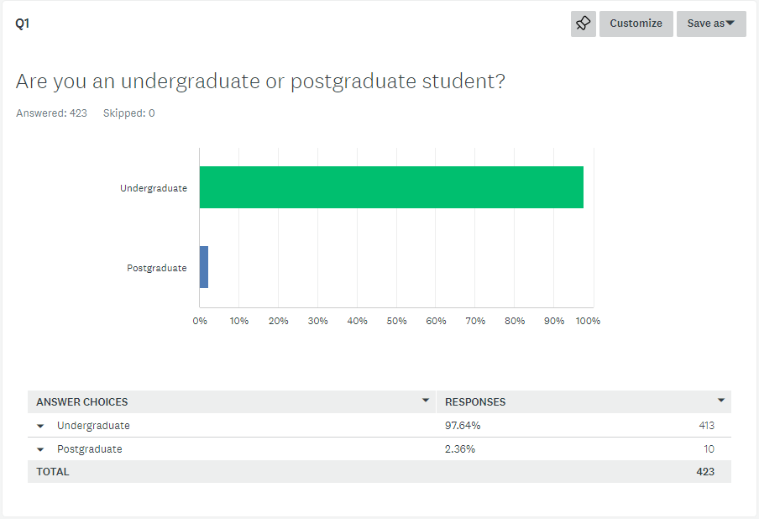
Appendix 1 – Student Voice Survey Two 2021/22

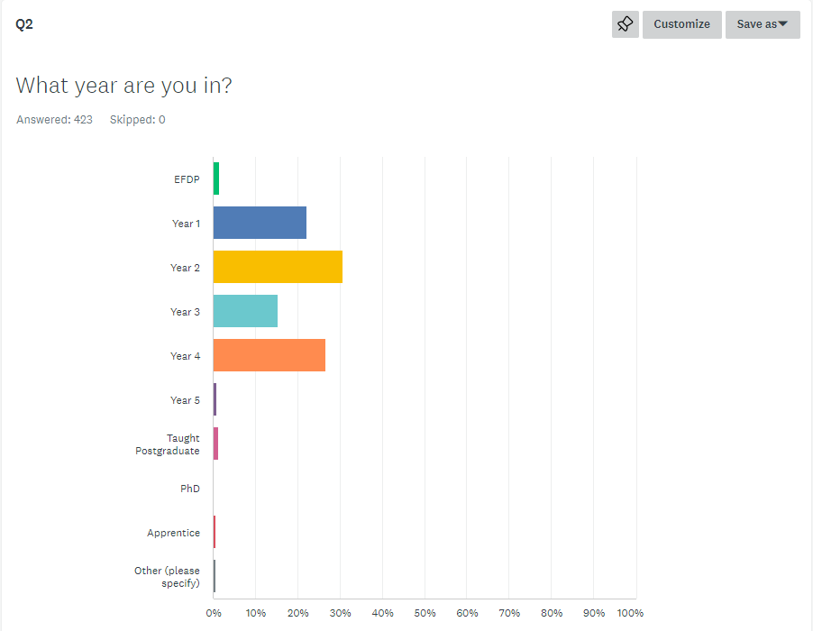

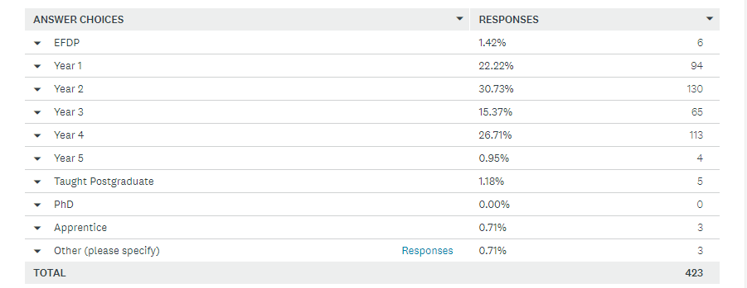

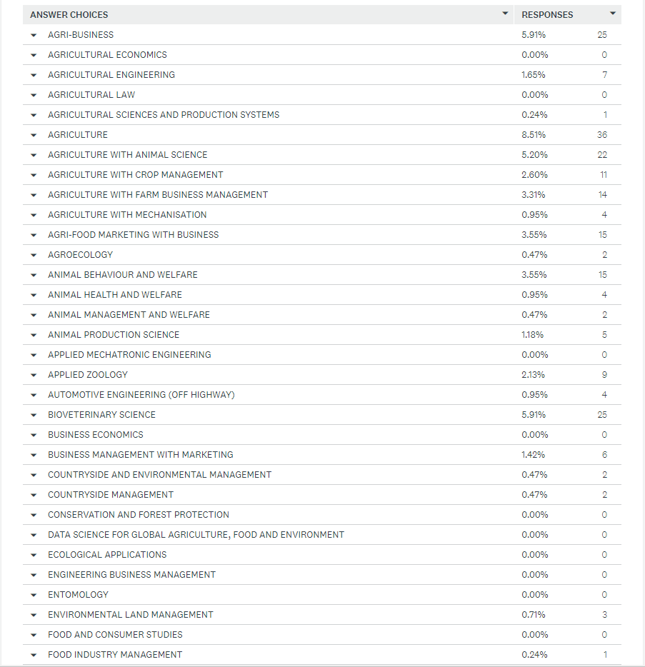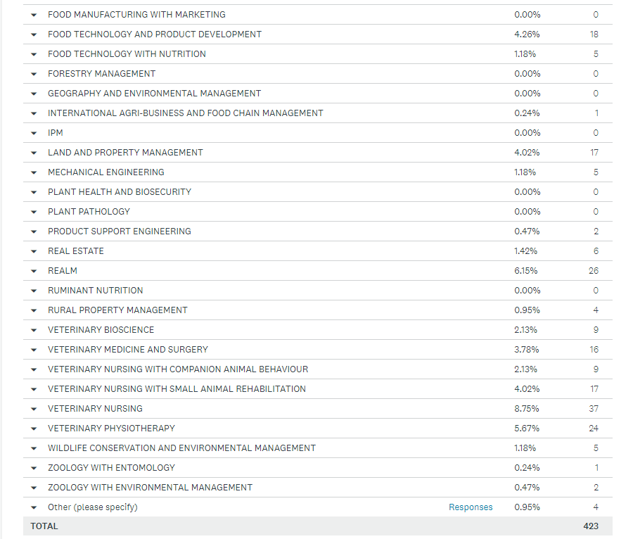

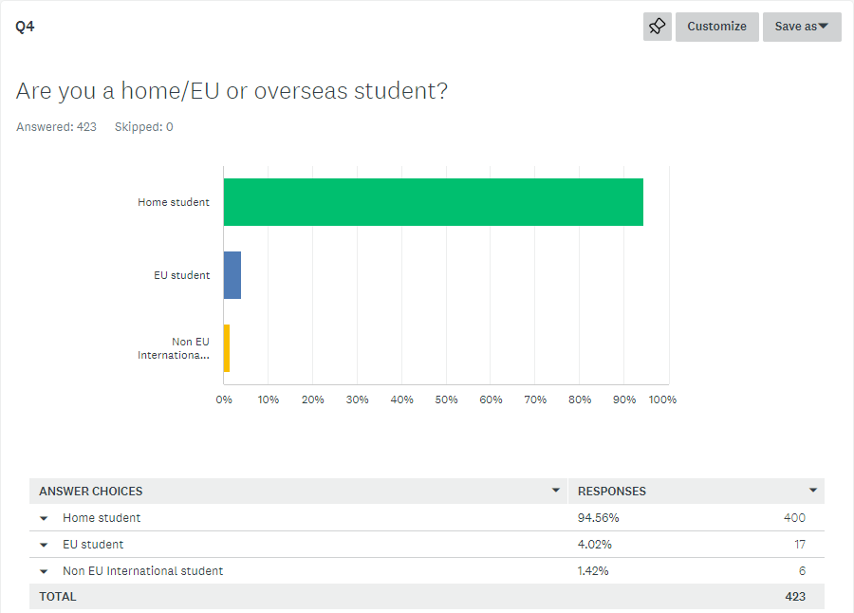

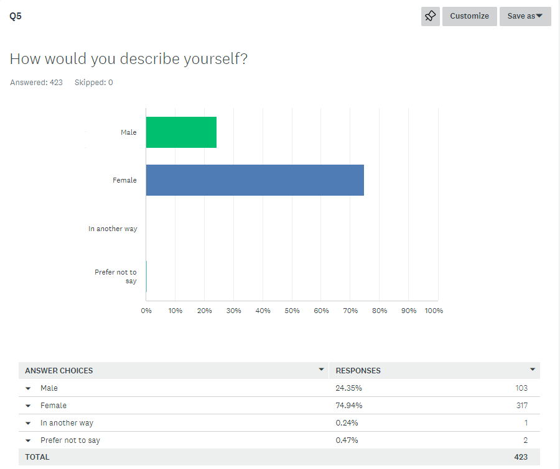

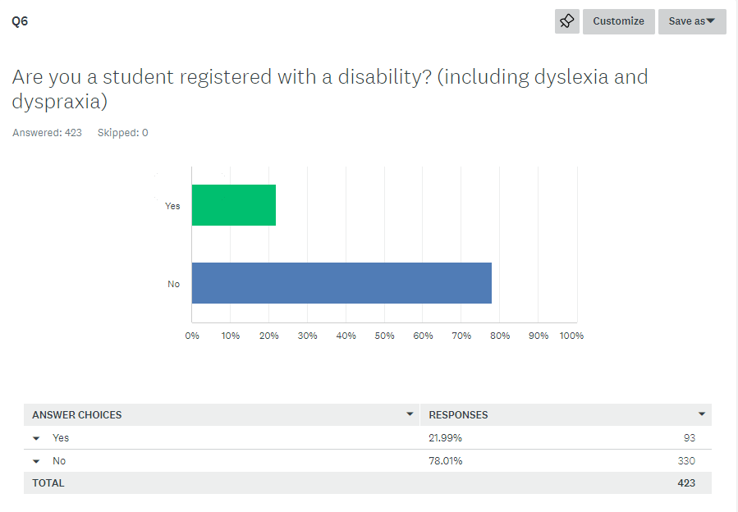

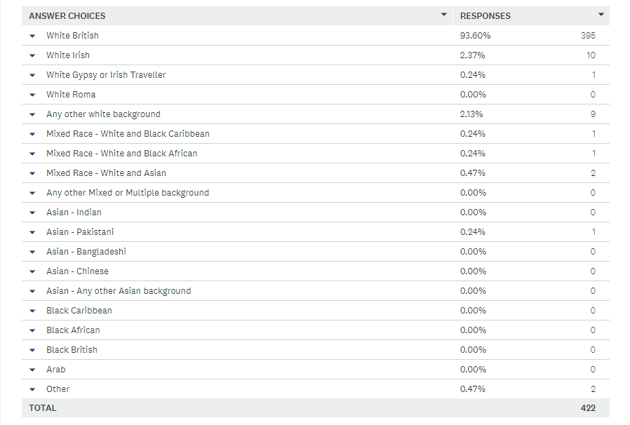

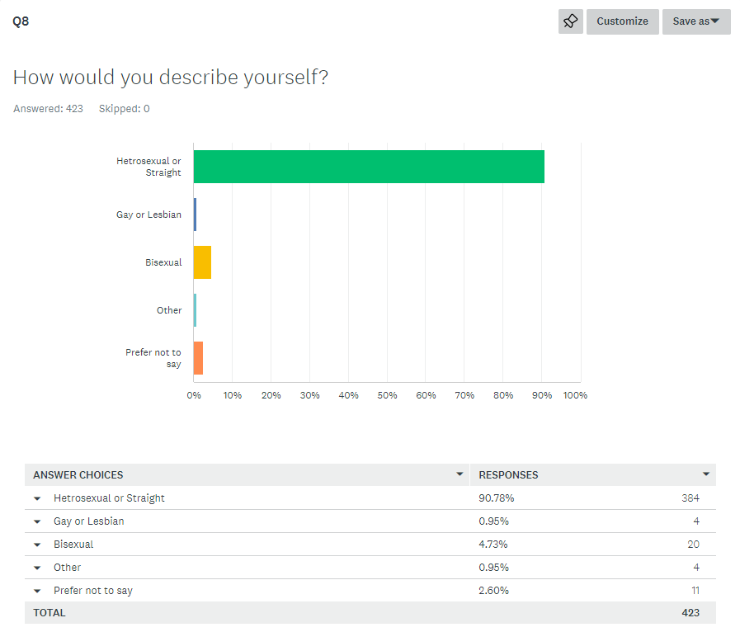

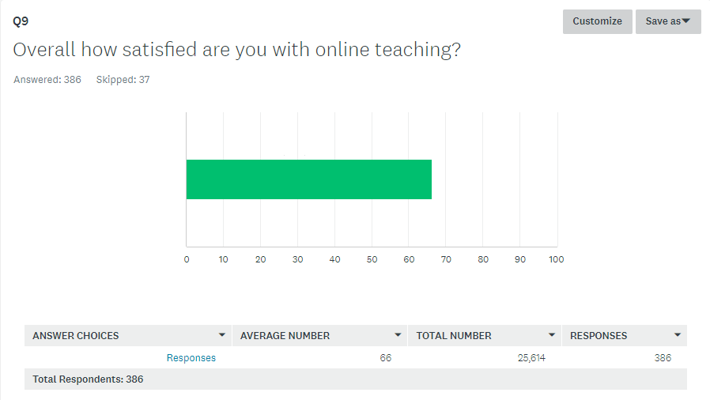

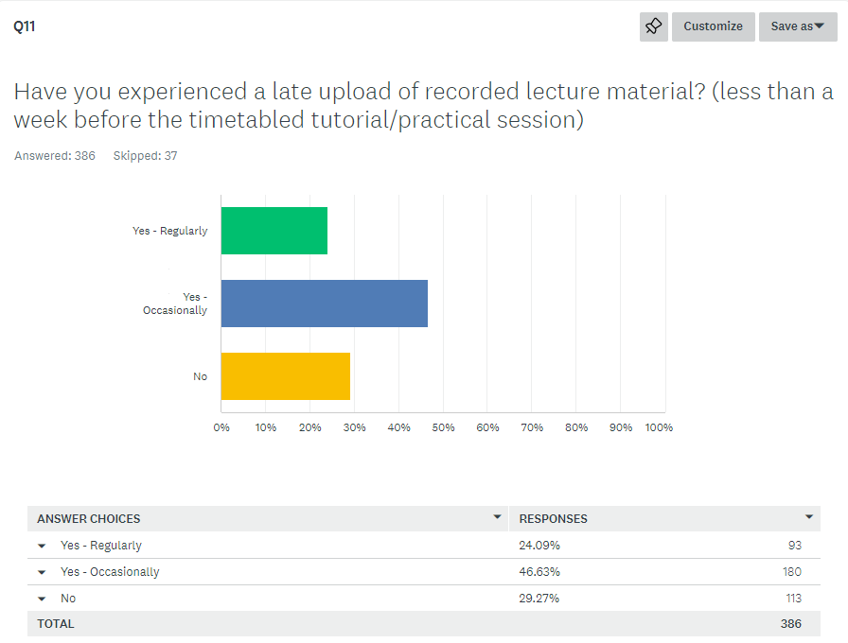

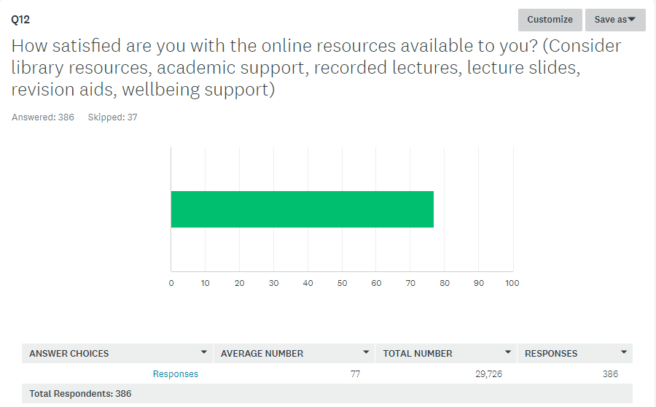

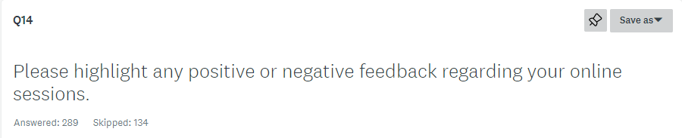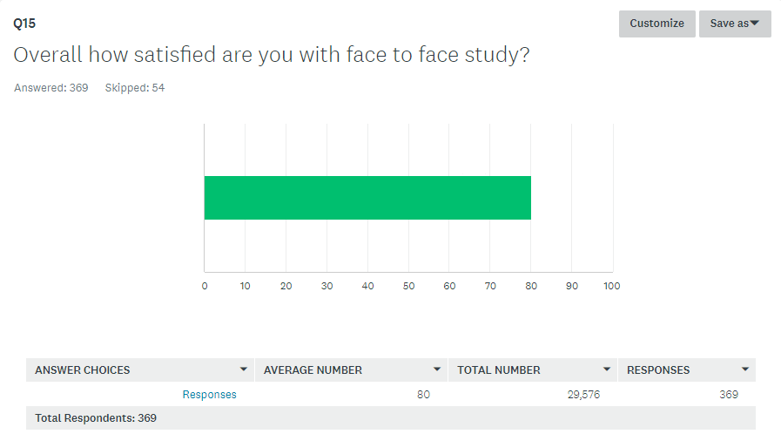

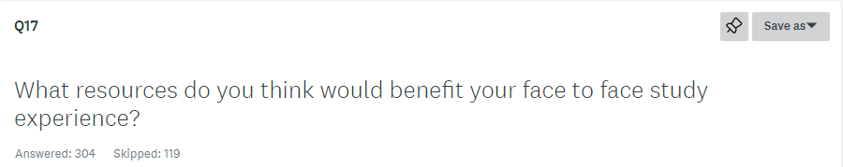

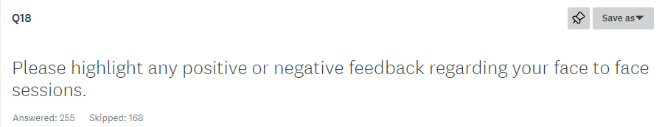

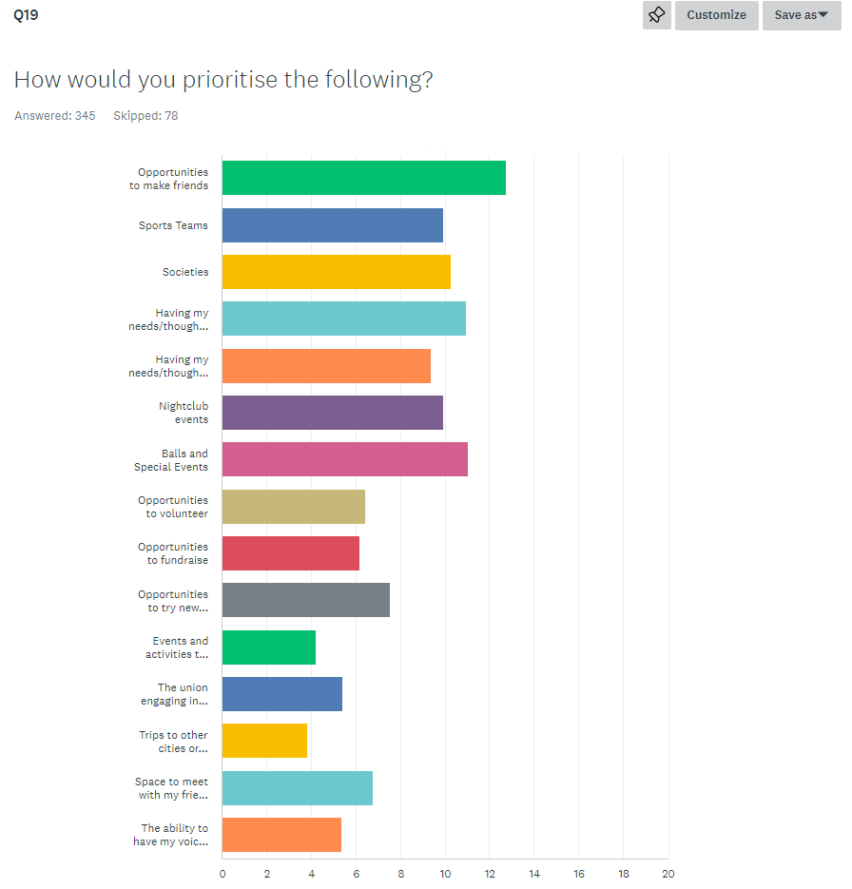
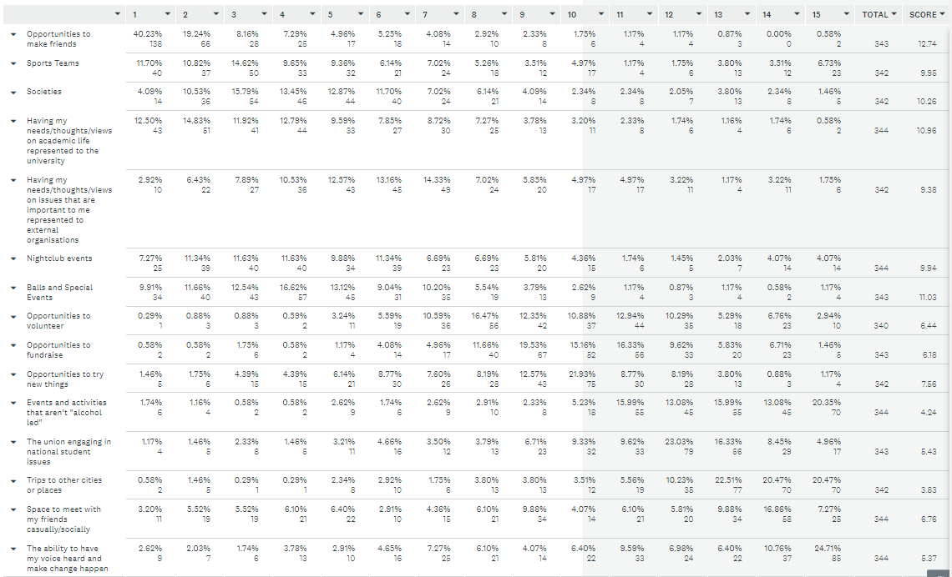

Q.20. Which, if any, of the following would you be interested in getting (more) involved with at Harper in the future? (please tick as many boxes as you like)
